Create a new environment – Anaconda Navigator

1. Click **create**
2. Enter Environment name
3. Click Create

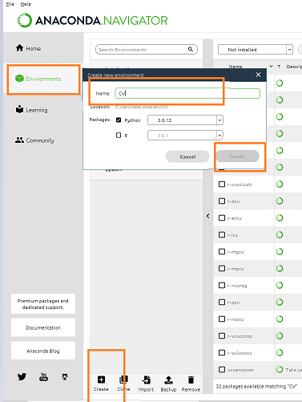

The new environment is ready now

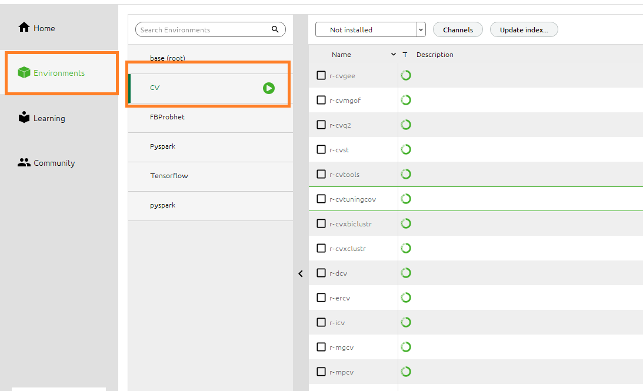

List all environments in Anaconda Prompt

conda env list

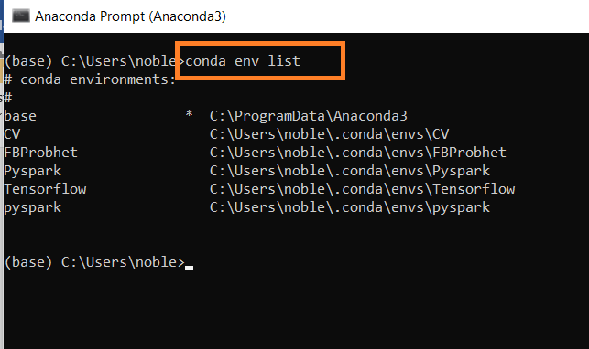

Activate new environment – CV

activate CV

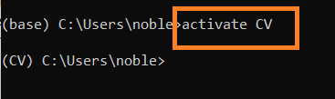

Once CV environment is active – Install open CV

conda install -c conda-forge opencv

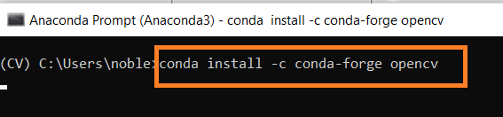

Type y and press enter to proceed

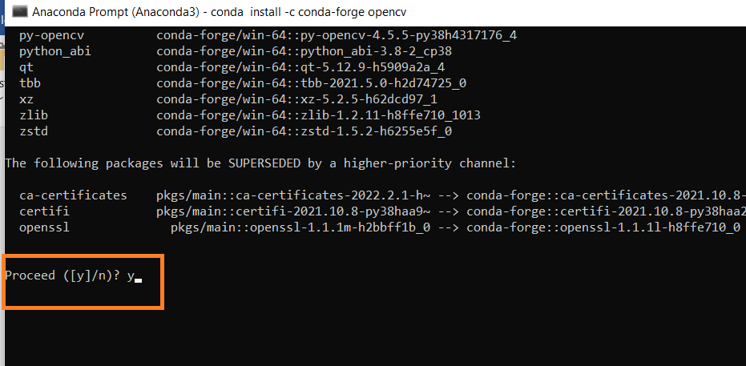

Open CV Install complete

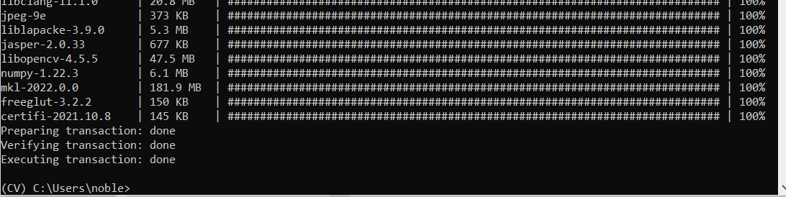

Open Anaconda Navigator –

* Check NumPy, Pandas, Matplotlib, Seaborn under environment CV

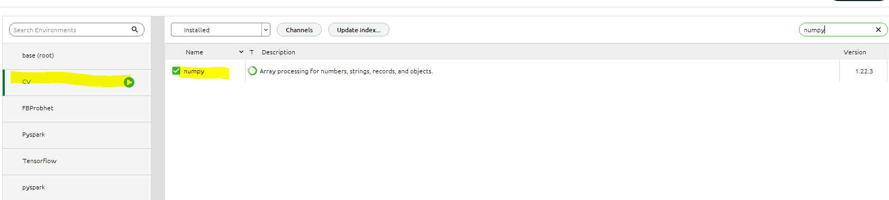

Install Pandas

Select Pandas, click – Apply

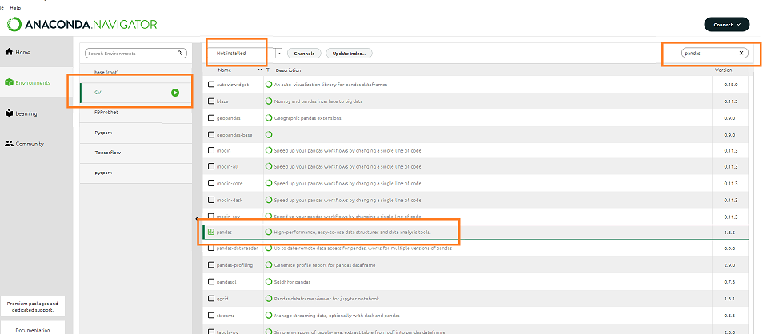

Next Screen Click – Apply

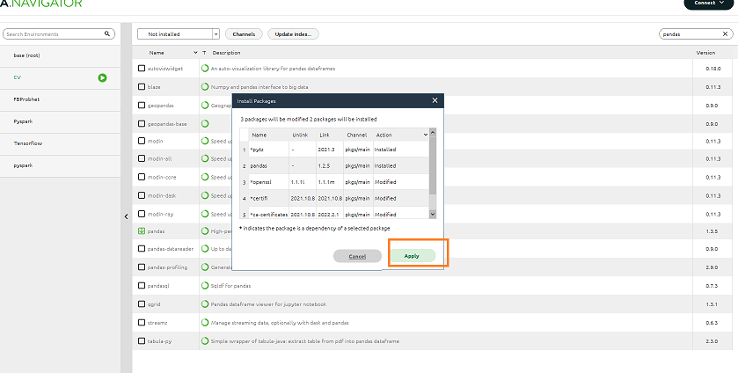

Install Matplotlib

Select Matplotlib click – Apply

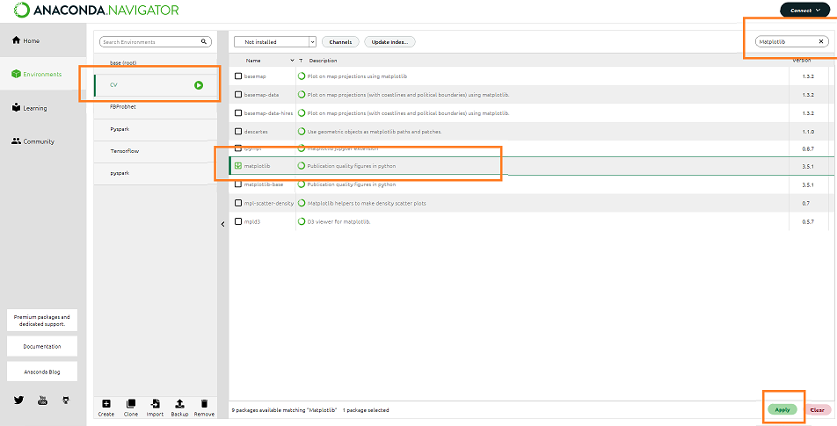

Next Screen Click – Apply

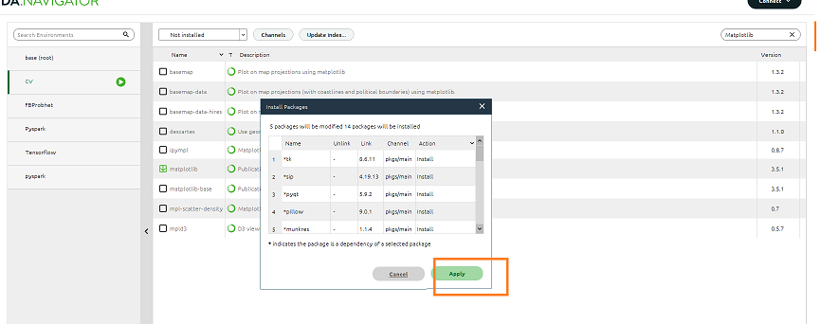

Install Seaborn

Select Seaborn click – Apply

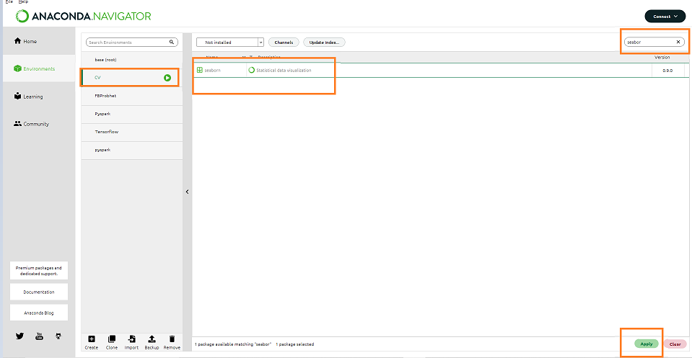

Next Screen Click – Apply

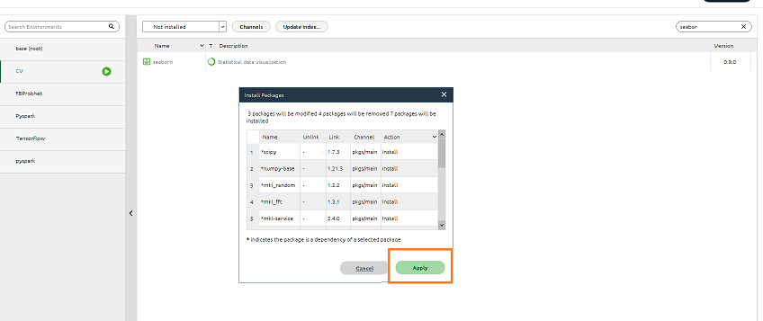

Open Anaconda Navigator –

* Select the new environment -CV
* Click Install Button Jupyter notebook
* Once installation is complete click the Launch Button to open the jupyter notebook

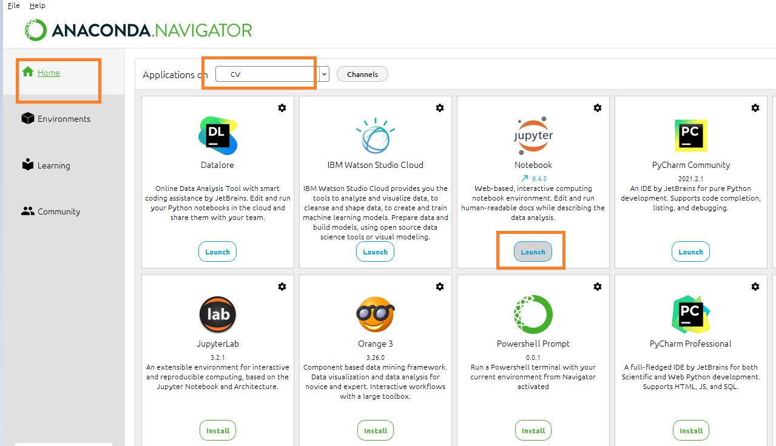

Open a new notebook type

import cv2

import numpy as np

import pandas as pd

import matplotlib.pyplot as plt

import seaborn as sns

The statement completes without any error

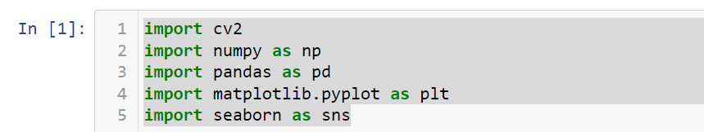

Install dlib

Activate new environment – CV

activate CV



Install DLIB

Type in the command prompt of CV

conda install -c conda-forge dlib

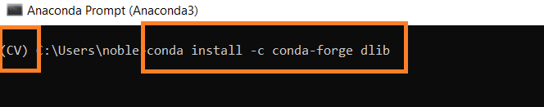

Proceed Y/N - > Type Y

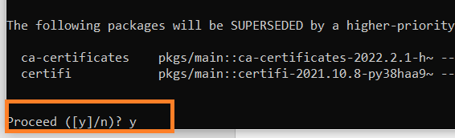

After install import DLIB in Jupyter Notebook

